PROBLEM STATEMENT

|  |  |
| --- | --- |
| Date | 08 October 2022 |
| Team ID | PNT2022TMID03254 |
| Project Name | Intelligent Vehicle Damage Assessment and Cost Estimator for Insurance Companies |
| Maximum marks | 2 Marks |

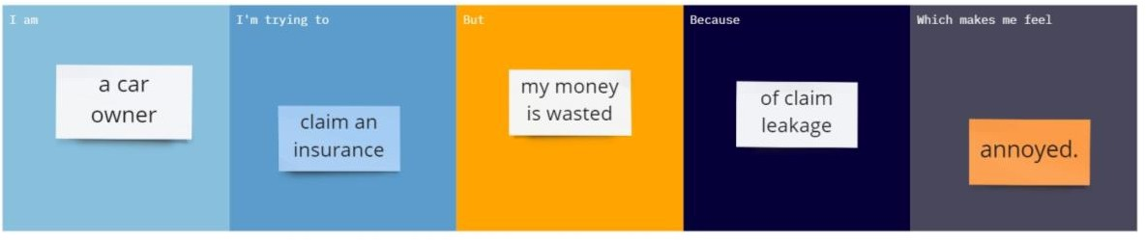

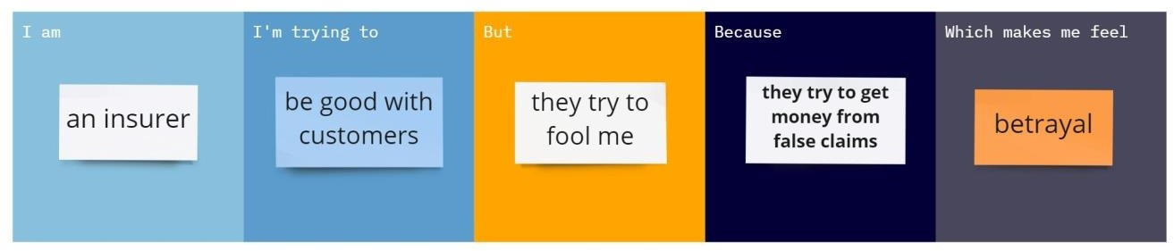

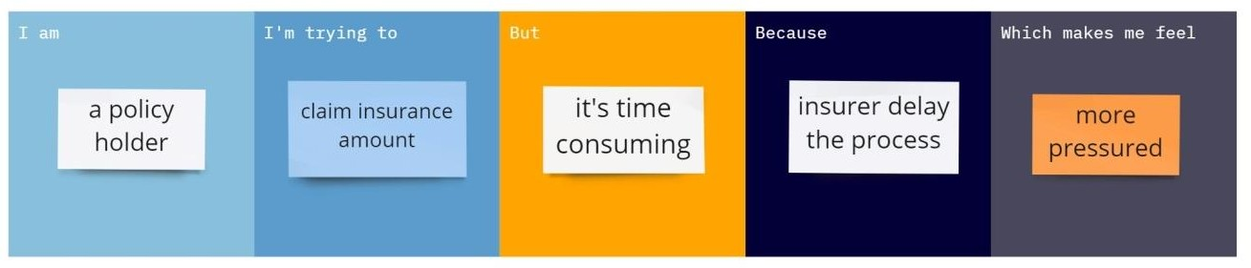

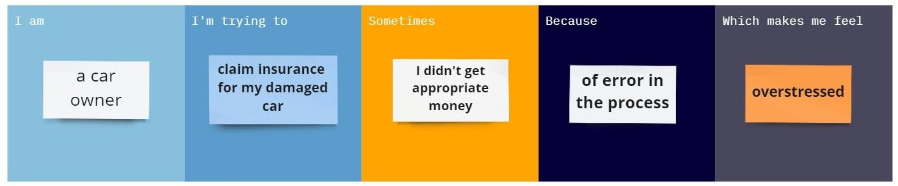

|  |  |  |  |  |  |
| --- | --- | --- | --- | --- | --- |
| **Problem Statement (PS)** | **I am** | **I’m trying to** | **But** | **Because** | **Which makes me feel** |
| PS-1 | a car owner | claim an insurance | my money is wasted | of claim leakage | annoyed |
| PS-2 | an insurer | be good with customers | they try to fool me | they try to get money from false claims | betrayal |
| PS-3 | a policy holder | claim insurance amount | It’s time consuming | insurer delay the process | more pressured |
| PS-4 | a car owner | claim insurance for my damaged car | I didn’t get appropriate money | of error in process | overstressed |